161.326 Assignment One
Alex Gibson - 07120141
Question One:

By generating suitable random data, show that it is possible to find a statistically significant (non-zero) slope in a univariate regression situation even when the true model has a slope of zero:

Assumptions:
The model chosen for this was a normal (Gaussian) distribution, with y ranging between 0 to 2 and x ranging from 0 to 100, sample size of 50. Note: the x range and sample sized were varied for testing during this experiment.

Hypothesis:
H0: yhat == 0, slope is non-significant for a sample taken from a normally distributed model.

Ha: yhat != 0, slope is significant for a sample taken from a normally distributed model.

Significance Value chosen for this test = .05

Testing:
During multiple single tests, p-value results were extremely varied, so in python a loop was set up to generate the test multiple times and collect the results to find the average p-value, Figure 1.1 (Appendix A) shows the p-values of the proposed test being undertaken 100,000 times, you can see from this that the results are entirely uniform from 0 to 1.

Figure 1.1 shows that we have results under and above our significance level, which would mean we would have trouble choosing either the null or alternative hypothesis. We could chose to reject the null hypothesis in favor of the alternative, but we would have to justify some results having a lower significance than our chosen significance level, and we could also say the same about accepting the null hypothesis, we cannot justify a lot of results being over the significance level.

The only result is that we have a completely random chance of producing a significant slope from a model of zero slope.

When changing the range of x I found no significance to the histograms (Figure 1.2), They still offer no clear choice of hypothesis. However, when adding an out-lier to the sample data (Still with normal distribution), the P-values result is skewed toward 1, this is shown in Figure 1.3.

My conclusion is that no conclusion can be drawn from this test without either making a type I or type II error.

Question Two:

Generate some data based on Data-set A1 and then train Perceptrons to separate the different classes. Start by separating classes a and b, plot the data and the linear classification line. Then do the same thing for all four classes. How well can the algorithm do? Explain why it does not always work perfectly.

- Figure 2.1 shows the complete data-set on one graph
- Figure 2.2 shows A and B and the line of linear separability
- Figure 2.3 shows A separated from the rest
- Figure 2.4 shows B separated from the rest

Result from Single Layer Perceptron on A and B:

- Set A and B
[[ 50. 0.]
[ 0. 50.]]
1.0

Results from Single Layer Perceptrons on complete Set:

- Set A and the Rest
[[ 104. 0.]
[ 46. 50.]]
0.77
- Set B and the Rest
[[ 126. 3.]
[ 24. 47.]]
0.865
- Set C and the Rest
[[ 85. 33.]
[ 65. 17.]]
0.51
- Set D and the Rest
[[ 150. 49.]
[ 0. 1.]]
0.755

Question Two Continued:

On the set A separated from B the perceptron can do very well, this is because the intersection of the the sets areas is the empty set, there is no overlapping data. The single layer perceptron suits this type of separation, this is because of the decision boundary being a straight line. Thus separating A from B with a straight line can be done perfectly, which gives the 100% confusion matrix result stated above.

This is not the same for the entire set, there are overlaps within the set, it can still perform linear separation, however, the network will make some mistakes on classifying one set from the other. As you can see from figure 2.3, on one side of the classification line shows some predictors of data set C and D, and the same can be said for Figure 2.4.

So the single layer perceptron algorithm is suited to perfectly separated data, however if the data does have some over-lap, a multilayer perceptron would be more suited, this is because in a multilayer perceptron the decision boundary is non-linear and can wrap around sets, producing more accurate predictions.

Question Three:

Modify the MLP code so that it works as an auto-associator (i.e., so that the network learns to reproduce the inputs at the output layer, as was covered in the lecture slides). Then use the numbers in the noisy data-sets to see if you can reproduce the correct versions. How good are the results?

Assumptions:
Since the MLP is to be used as a auto-associator, the inputs are the outputs for the learning of the Perceptron.

Training:
To start with, I had no idea what amount of hidden layers should be used. A for loop was setup to produce the learning error for the training of each network with x amount of hidden layers, x ranging from 1 to 30, this is shown in figure 3.1. As you can see from the data, there is a almost a linear relationship between the learning iterations and learning error when one hidden layer is used, we tend toward exponential decay as the layers increase to 15, but strangely enough, start turning back to a linear as we increase from 15.

This is showed that the best setup for this problem is around 15 layers, figure 3.2 shows the learning error with layers around 15, 15 is still be consecutively the best performer.

The only problem we have is that the learning error for 15 layers computing 35 bits of information converges around 1.0 e^(-4). This does not allow the network to completely learn the set, thus resulting in a confusion matrix where some images are thought to be others, shown in figure 3.3, 42% is less than optimal predictions for the learning network.

To test the auto-associator on the noisy sets, when the original set cannot be fully learnt within the network (Within reasonable time that is), will be unsuccessful, shown in figure 3.4, we can see that it cannot associate the noisy images very well.

However, I did manage to successfully train the network using images of 15 bits, using 8 Layers (20,000 iterations) produced 100% learning, which could accurately associate the two images to 75% and 80% respectively.

So in conclusion, this algorithm is not feasible to use on a data set of 35 bits per image, lower bit images are fine, but the network could not learn the entire set of images when all 35 bits were used.

Question Four:

Using the prostate cancer training data, find the best subset regression model for each number of possible predictors. Fit each of these models to the test data, and thus identify the best model(s).

My approach to this problem was to brute force all possible combinations of the predictor groups, gathering the RSS of each set and comparing to the current best for that group. Table 4.1 shows the results of the generation. Note: Training data has been standardized, and the last column is the intercept.

Now all that’s left is to standardize the test data with the training data’s mean and variance. So now the test data is around 0 and between 1 and -1 in relation to the training set.

Results:
Table 4.2 show the RSS of both the training and the test sets, we can clearly see that both the group with two predictors and four predictors have the lowest RSS in the test set, and since the two predictors set has a slightly lower RSS value than four I would be select that as the best predictor for prostate cancer.

Appendix A:

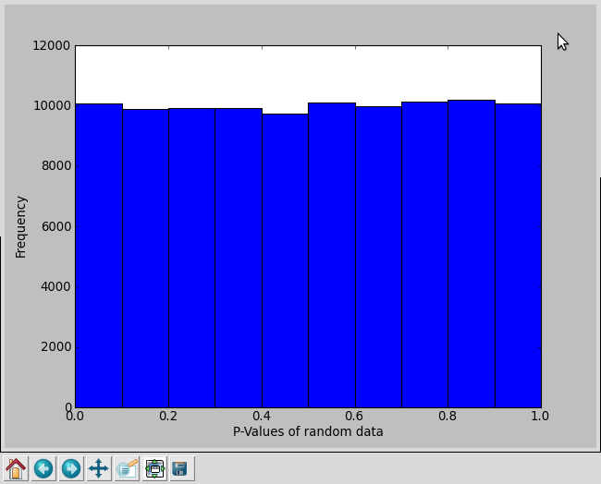
Figure 1.1: Histograms of P Values (Sample size = 100,000)

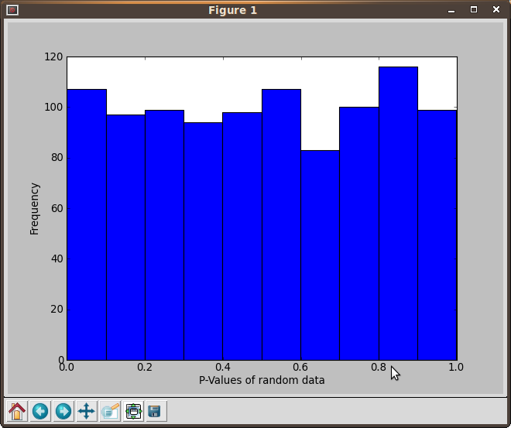
Figure 1.2: Histograms of P Values of x range 0 - 10000000 (Sample Size = 1000)

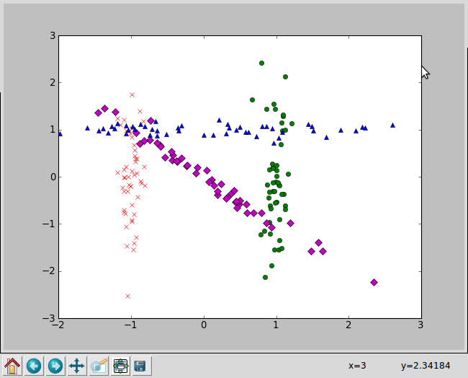
Figure 2.1: Showing full data-set (Crosses = A, Circles = B, Diamonds = C, Triangles = D)

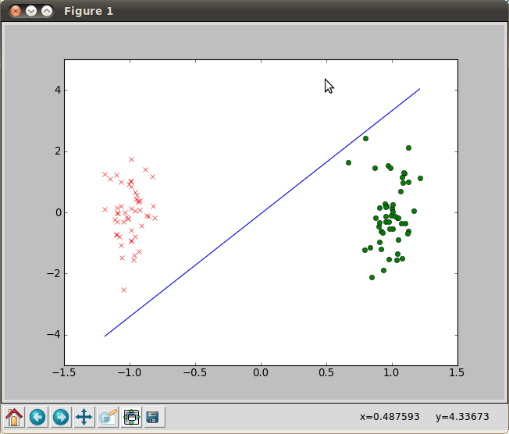
Figure 2.2: A and B with line of Linear Separability.

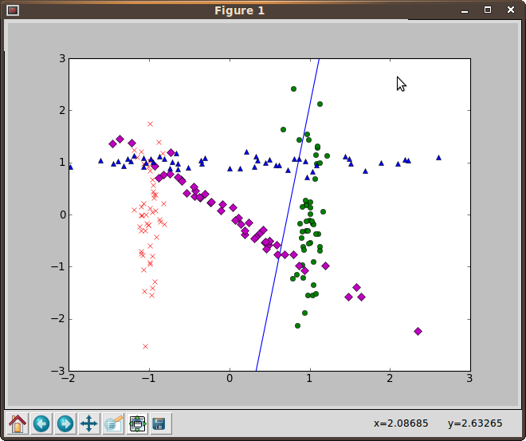
Figure 2.3: A and the rest with line of Linear Separability

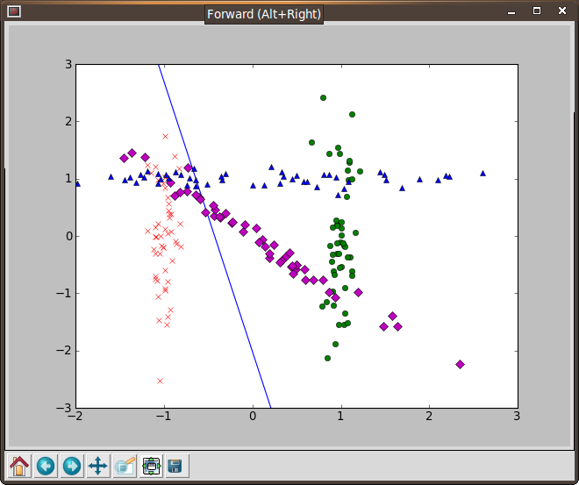
Figure 2.4: B and the rest with line of Linear Separability

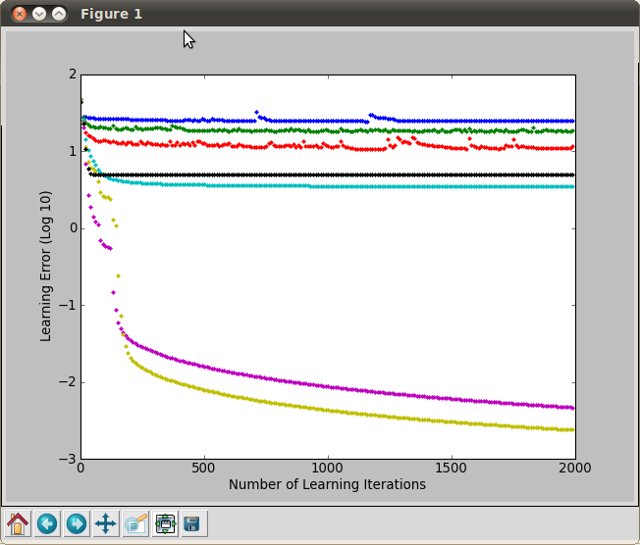
Figure 3.1: Learning rate for multilayer perceptron with the following layers:
  - Blue = 1 Layer
  - Green = 2 Layers
  - Red = 3 Layers
  - Teal = 5 Layers
  - Purple = 10 Layers
  - Brown = 15 Layers
  - Black = 30 Layers

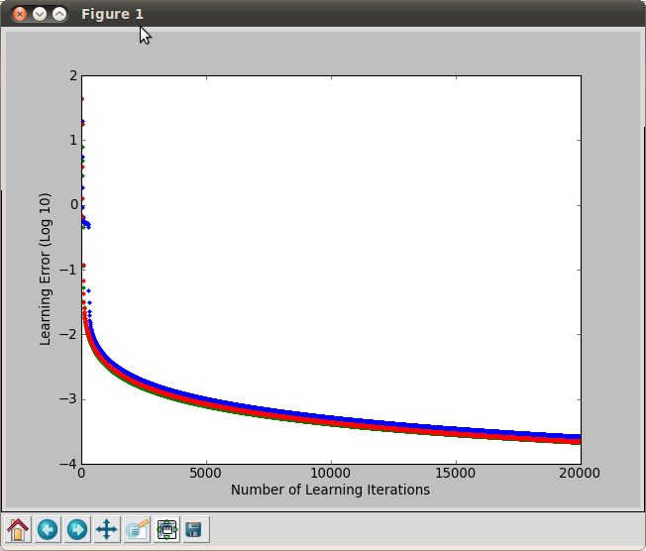
Figure 3.2: Learning rate for multilayer perceptron with the following layers:
  - Blue = 14 Layer
  - Green = 15 Layers
  - Red = 16 Layers

Confusion matrix is:
[[ 3. 0. 0. 0. 0. 0. 0. 0. 0. 0.]
[ 1. 3. 0. 0. 0. 0. 0. 0. 0. 0.]
[ 2. 0. 2. 0. 0. 0. 0. 0. 0. 0.]
[ 0. 0. 0. 0. 0. 0. 0. 0. 0. 0.]
[ 2. 0. 0. 0. 5. 0. 0. 0. 0. 0.]
[ 1. 1. 0. 0. 0. 2. 0. 0. 0. 0.]
[ 1. 0. 1. 0. 0. 1. 0. 0. 0. 0.]
[ 0. 1. 0. 0. 0. 0. 0. 0. 0. 0.]
[ 3. 1. 4. 0. 0. 0. 0. 0. 0. 0.]
[ 1. 0. 0. 0. 0. 0. 0. 0. 0. 0.]]
Percentage Correct: 42.8571428571

Figure 3.3: Confusion Matrix for 15 layers with 20000 learning iterations.

Confusion matrix is:
[[ 2. 1. 0. 0. 1. 0. 0. 0. 0. 0.]
[ 1. 1. 0. 0. 0. 1. 0. 0. 0. 0.]
[ 3. 2. 2. 0. 0. 0. 0. 0. 0. 0.]
[ 1. 0. 0. 0. 0. 0. 0. 0. 0. 0.]
[ 0. 0. 0. 0. 1. 0. 0. 0. 0. 0.]
[ 2. 2. 0. 0. 1. 2. 0. 0. 0. 0.]
[ 0. 0. 2. 0. 1. 0. 0. 0. 0. 0.]
[ 1. 0. 0. 0. 0. 0. 0. 0. 0. 0.]
[ 3. 0. 0. 0. 0. 0. 0. 0. 0. 0.]
[ 1. 0. 3. 0. 1. 0. 0. 0. 0. 0.]]
Percentage Correct: 22.8571428571

Figure 3.4: Confusion Matrix for noisy set 1, same network as above.

Confusion matrix is:
[[ 7. 2. 0. 0. 1. 0. 0. 0. 0. 0.]
[ 0. 3. 0. 0. 1. 0. 0. 0. 0. 0.]
[ 0. 0. 1. 0. 1. 1. 0. 0. 0. 0.]
[ 0. 0. 0. 0. 0. 0. 0. 0. 0. 0.]
[ 1. 0. 0. 0. 0. 0. 0. 0. 0. 0.]
[ 0. 0. 0. 0. 0. 1. 0. 0. 0. 0.]
[ 1. 0. 2. 0. 0. 0. 0. 0. 0. 0.]
[ 0. 0. 0. 0. 1. 1. 0. 0. 0. 0.]
[ 2. 1. 1. 0. 0. 0. 0. 0. 0. 0.]
[ 3. 0. 3. 0. 1. 0. 0. 0. 0. 0.]]
Percentage Correct: 34.2857142857

Figure 3.4: Confusion Matrix for noisy set 1, same network as above.

One Predictor:
Rss: 96.2814, Predictors: [8], Betahat : [ 2.4523]

Two Predictors:
Rss: 44.5286, Predictors: [0, 8], Betahat : [ 1.0839],
[ 2.4523]

Three Predictors:
Rss: 37.0918, Predictors: [0, 1, 8], Betahat : [ 0.9545],
[ 0.1652],
[ 2.4523]

Four Predictors:
Rss: 34.9077, Predictors: [0, 1, 4, 8] Betahat : [ 0.7908],
[ 0.1648],
[ 0.0934],
[ 2.4523]
Five Predictors:
Rss: 32.8149, Predictors: [0, 1, 3, 4, 8] Betahat : [ 0.7688],
[ 0.1205],
[ 0.2954],
[ 0.1167],
[ 2.4523]
Six Predictors:
Rss: 32.0694, Predictors: [0, 1, 3, 4, 7, 8] Betahat : [ 0.7183],
[ 0.1261],
[ 0.2893],
[ 0.1004],
[ 3.6628],
[ 2.4523]
Seven Predictors:
Rss: 30.5397, Predictors: [0, 1, 3, 4, 5, 7, 8], Betahat : [ 0.8362],
[ 0.1260],
[ 0.2658],
[ 0.1314],
[-0.3688],
[ 6.3782],
[ 2.4523]

Eight Predictors:
Rss: 29.4373, Predictors: [0, 1, 2, 3, 4, 5, 7, 8], Betahat : [ 0.8729],
[ 0.1385],
[-1.0800],
[ 0.3047],
[ 0.1289],
[-0.3970],
[ 7.5654],
[ 2.4523]
All Predictors:
Rss: 29.4263, Predictors: [0, 1, 2, 3, 4, 5, 6, 7, 8] Betahat : [ 0.8765],
[ 0.1373],
[-1.0534],
[ 0.3056],
[ 0.1280],
[-0.3987],
[-0.0146],
[ 8.0054],
[ 2.4523]

Table 4.1: Shows the combinations of predictors with the lowest residual sum of squares.

Predictors | Training RSS | Testing RSS
[8] | 96.2814241405 | 31.7019427927
[0,8] | 44.5286316858 | 14.3921188751
[0,1,8] | 37.0918229986 | 17.2102562441
[0,1,4,8] | 34.9077261586 | 14.4438359955
[0,1,3,4,8] | 32.8149841999 | 15.3458517675
[0, 1, 3, 4, 7, 8] | 32.0694379895 | 16.2418600159
[0, 1, 3, 4, 5, 7, 8] | 30.5397676571 | 18.0999634554
[0, 1, 2, 3, 4, 5, 7, 8] | 29.437300581 | 17.4608187118
[0, 1, 2, 3, 4, 5, 6, 7, 8] | 29.4263839583 | 17.5898669677

Table 4.2: Showing the test and training RSS side by side.

